Table of Contents
- Abstract………………………………………………………………..1
- Introduction…………………………………………………………..1

2.1Background……………………………………………………1

2.2 Why the Project is Necessary………………………………….1

2.3 Challenges Faced………………………………………………2

2.4 Project Novelty………………………………………………..2

2.5 Motivation……………………………………………………..3

2.6 New Contributions…………………………………………….3

2.7 Research Gaps…………………………………………………3

2.8 Objectives……………………………………………………..3

2.9 Significance……………………………………………………4
- Literature Review……………………………………………………..4

3.1 Existing Similar Projects………………………………………4

3.2 Limitations of Previous Works………………………………..5

3.3 Features and Improvements in This Project…………………..5
- Methodology…………………………………………………………...6
  - Design Approach……………………………………………...6
  - Implementation Strategy……………………………………...6
  - Tools & Techniques…………………………………………..7
  - Testing & Verification………………………………………..7
  - Project Flow…………………………………………………..7
  - Project Output…………………………………………………8
- Implementation………………………………………………………..9
  - Network Topology…………………………………………….9
  - VLAN & Inter‑VLAN Routing (Campus)…………………….12
  - Access Switch Configuration………………………………….15
  - Remote Site Serial Link Configuration………………………..18
  - Inter‑Campus Static Routing…………………………………..21

  - Access Control List (ACL)……………………………………. 23
  - Email Server Configuration…………………………………… 23
  - Web Server Configuration…………………………………….. 25
  - IoT Integration – Temperature Sensor & Email Alerts………… 26
- Results and Discussion………………………………………………… 30
  - Connectivity Tests……………………………………………… 30
  - ACL Verification………………………………………………. 34
  - Email Automation Tests……………………………………….. 34
  - System Limitations…………………………………………….. 35
- Limitations & Challenges……………………………………………… 35
  - Network Design Challenges…………………………………… 35
  - Hardware/Software Limitation………………………………… 35
  - Practical Issues Encountered…………………………………… 36
- Risks and Mitigation…………………………………………………… 36
- Knowledge Categories (K1–K8)……………………………………… 37
- Complex Engineering Problem Attributes (P1–P7)………………… 38
  - Complex Engineering Activities……………………………… 39
- Conclusion……………………………………………………………...40
- Future Work……………………………………………………………40
- References……………………………………………………………… 41
- Appendix: Screenshot Commands and Placeholders…..…………….42

Abstract
This project presents the design and implementation of a converged university campus network that integrates a main campus (with VLANs for IT, server room, animal science, and academic buildings) with a remote site connected via a four‑router serial chain using HWIC‑2T modules. The network provides full IPv4 connectivity through static routing, centralized email services (SMTP/POP3), and fine‑grained access control via an extended ACL that restricts a specific remote PC to only the administrator’s PC and a dedicated web server. An IoT subsystem was developed using a Home Gateway and an SBC‑PT board with an analog temperature sensor connected to the D0 pin. The SBC‑PT runs a Python script that reads the temperature and automatically sends email alerts to the administrator when the temperature reaches 7 °C (turn ON air conditioners) or drops below 7 °C (turn OFF air conditioners). The entire network was simulated and verified in Cisco Packet Tracer, demonstrating practical skills in VLAN segmentation, static routing, ACL configuration, email server deployment, and IoT programming.

Introduction

Background
Modern universities require robust, secure, and scalable network infrastructures to support multiple departments, remote campuses, and IoT‑based environmental monitoring. Traditional networks often lack automated alerting for temperature control (e.g., for server rooms or lecture halls) and do not provide fine‑grained access restrictions for remote users. This project addresses these gaps by designing a network that combines traditional campus VLANs with a remote site over serial links, an extended ACL for host‑level restriction, and an IoT‑driven temperature alert system that sends real emails to the administrator.

Why the Project is Necessary
Modern university campuses often operate separate networks for different departments, leading to inefficiencies in resource sharing, security vulnerabilities, and lack of centralized monitoring. Additionally, environmental conditions such as temperature in server rooms or lecture halls are rarely monitored automatically, resulting in energy waste or equipment damage. This project addresses these issues by designing a converged network that integrates a main campus with a remote site, provides fine‑grained access control, and automates temperature alerting via email.

Challenges Faced
During the implementation, several challenges were encountered and resolved:
- Inter‑VLAN routing misconfigurations – Initial pings between VLANs failed due to missing SVIs on Core Exchange1; these were corrected by enabling `ip routing` and assigning IP addresses to each VLAN interface.
- Native VLAN mismatch – The trunk between Core Exchange1 and Access Switch1 had mismatched native VLANs (1 vs 100), causing connectivity loss; setting native VLAN 100 on both ends fixed the issue.
- ACL direction error – Applying ACL 101 inbound on R4’s G0/0 did not block outgoing traffic from PC_C_HR; changing to outbound resolved the restriction.
- Email delivery failure from SBC‑PT – The `EmailClient` object was unreliable; switching to the built‑in `sendEmail()` function and ensuring the mail server had the correct domain name and user accounts solved the problem.
- Home Gateway unresponsiveness – The device initially did not respond to ping or HTTP; replacing it with a fresh unit and assigning a static IP restored functionality.

Project Novelty
The novelty of this project lies in the seamless integration of a traditional campus network with a remote site connected via a four‑router serial chain (using HWIC‑2T modules) combined with IoT‑driven environmental automation. Unlike previous works that either simulated IoT or lacked cross‑campus routing, this project uses a real programmable SBC‑PT board to read an analog temperature sensor and send actual email alerts. The extended ACL restricting a specific remote host to only two destinations demonstrates a zero‑trust approach at the network edge.

Motivation
The motivation stems from the need for energy efficiency and proactive maintenance in university campuses. Air conditioners often run unnecessarily when rooms are already cool, wasting electricity. By automatically notifying the administrator when the temperature reaches a set point (7 °C), the system enables timely manual control of HVAC systems. Additionally, the remote site connectivity mirrors real‑world scenarios where branch offices need secure, isolated access to central services.

New Contributions
This project makes the following new contributions:
- A validated configuration for using an SBC‑PT with `analogRead(0)` on a digital pin (D0) to read an analog temperature sensor – a workaround not documented in standard Packet Tracer guides.
- A reliable method for sending emails from an SBC‑PT using the `sendEmail()` function, bypassing the unreliable `EmailClient`.
- A working extended ACL that filters traffic leaving the remote site, allowing only specific host‑to‑host communication (PC_C_HR → Admin PC and web server).
- A complete, documented topology with static routing between a campus and a four‑router serial chain, including all configuration commands and verification steps.

Research Gaps
While many IoT automation projects exist, few address the integration of a legacy campus network with a serial‑connected remote site using Cisco Packet Tracer. There is a lack of clear documentation on how to program an SBC‑PT for analog sensor reading and email alerts when the Home Gateway lacks a rules engine. This project fills that gap by providing step‑by‑step configurations and a tested Python script that works within Packet Tracer’s limitations.

Objectives
The primary objectives of this project are:
- Campus Network Design – Implement VLANs (10,20,30,60,100) with inter‑VLAN routing on a Layer‑3 switch (Core Exchange1).
- Remote Site Connectivity – Connect a remote site using four Cisco 2911 routers with serial DCE links (HWIC‑2T) and router‑on‑a‑stick for local VLANs.
- Static Routing – Enable full IP communication between the campus and the remote site using static routes (no dynamic routing protocols).
- Access Control – Deploy an extended ACL on the border router (R4) to restrict a specific remote PC (PC_C_HR) to only the administrator’s PC (192.168.10.10) and a dedicated web server (192.168.10.200).
- Email Services – Configure a mail server (SMTP/POP3) with user accounts for administrators and the IoT device (sbc).
- IoT Automation – Integrate an analog temperature sensor with an SBC‑PT board that reads the temperature and sends automatic email alerts at 7 °C (turn ON ACs) and below 7 °C (turn OFF ACs).

Significance
This project demonstrates practical applications of advanced networking concepts (VLANs, static routing, extended ACLs) combined with IoT automation. It serves as a blueprint for university campuses that need to monitor environmental conditions (e.g., server rooms, lecture halls) and automatically notify staff via email. The ACL implementation shows how to enforce zero‑trust principles at the network edge, allowing only pre‑approved communication.

Literature Review

Existing Similar Projects
Several studies have explored campus network designs:
- Sita et al. (2019) implemented VLANs for student/faculty separation and basic IoT connectivity but lacked multi‑campus routing and fully integrated server services.
- Ni & Zeng (2025) proposed a layered smart campus architecture focusing on data security, but without real IoT device integration.
- Wijonarko et al. (2023) used VLAN segmentation for IoT devices but did not include centralized DHCP, DNS, or inter‑campus routing.
- Fu & Lu (2012) focused on VLAN technology for large user populations, but IoT and cross‑campus connectivity were absent.

Limitations of Previous Works
Common shortcomings include:
- Single‑campus focus – No seamless integration of a remote site.
- Limited IoT automation – Most works simulated IoT or used only simple on/off control without email alerts.
- Weak security – ACLs were either missing or too permissive.
- Incomplete server services – Email, web, and DNS were often omitted.

Features and Improvements in This Project
This project overcomes those limitations by:
- Implementing a four‑router serial chain for remote site connectivity, demonstrating WAN concepts.
- Using an extended ACL that restricts a specific remote host to only two destinations, providing granular security.
- Developing a Python script on SBC‑PT that reads an analog temperature sensor (using `analogRead(0)` on D0) and sends real emails via the campus mail server.
- Providing full static routing between the campus and remote site, verified by ping tests.
- Documenting step‑by‑step configurations for all devices, making it reproducible.

Methodology

Design Approach
The network was designed with a modular, hierarchical approach:
- IP Addressing – Private IPv4 addresses: campus VLANs in 192.168.x.0/24, remote site in 10.10.x.0/24, serial links in 200.200.200.0/24, 201.201.201.0/24, 202.202.202.0/24, and the inter‑campus link in 203.203.203.0/24.
- VLAN Planning – Campus: 10 (IT_CELL), 20 (SERVER_ROOM), 30 (ANIMAL_SCIENCE), 60 (ACADEMIC), 100 (TRANSIT). Remote: 10 (Sales), 20 (Engineering), 30 (HR).
- Routing Strategy – Static routes on all routers; default routes on remote routers toward R4; default route on R4 toward Core Router; specific routes on Core Router for remote subnets.
- Security – Extended ACL 101 applied outbound on R4’s G0/0 to restrict PC_C_HR (10.10.30.20) to only 192.168.10.10 and 192.168.10.200.
- IoT Automation – SBC‑PT reads analog temperature from sensor on D0 using `analogRead(0)`, converts to Celsius, and sends email via `sendEmail()` when thresholds are crossed.

Implementation Strategy
Implementation followed a phased approach:
- Campus core – Configure Core Router, Core Exchange1 (Layer3 switch), access switches, VLANs, SVIs, and trunking.
- Remote site – Configure R1‑R4 with serial links, subinterfaces on R4, Switch A, Switch C, and end device static IPs.
- Interconnection – Connect R4 G0/0 to Core Router G0/1; add static routes.
- Email server – Configure SMTP/POP3, domain, users (admin, sbc).
- Web server – Enable HTTP on Server‑PT at 192.168.10.200.
- ACL – Create and apply ACL 101 on R4.
- IoT – Add Home Gateway, SBC‑PT, temperature sensor; program SBC‑PT with Python script.
- Testing – Ping tests, ACL checks, email delivery.

Tools & Techniques
- Cisco Packet Tracer 8.x – Network simulation, device configuration.
- Python (built‑in in SBC‑PT) – Scripting for temperature reading and email alerts.
- CLI commands – `show ip route`, `show access-lists`, `show vlan brief`, `show interfaces trunk`, `ping`, `sendEmail()`.

Testing & Verification
- Connectivity – Ping tests between all key devices (Admin PC, PC_A_Sales, PC_C_HR, mail server, web server).
- ACL – From PC_C_HR, ping Admin PC (success) and mail server (fail); browse web server (success).
- Email – Verify emails appear in Admin PC inbox when temperature crosses thresholds.
- Routing – Use `show ip route` to confirm static routes.

Project Flow
The project was executed in a structured, sequential flow to ensure each component worked before integrating the next. The steps were as follows:
- Campus core configuration – Configured Core Router, Core Exchange1 (Layer‑3 switch), VLANs, SVIs, trunk ports, and access switches. Verified inter‑VLAN routing with ping tests between devices in different VLANs.
- Remote site setup – Configured four routers (R1–R4) with serial DCE links using HWIC‑2T modules. Assigned IP addresses to serial interfaces and subinterfaces on R4. Configured Switch A and Switch C with VLANs 10,20,30 and trunking.
- Inter‑campus static routing – Connected R4 G0/0 to Core Router G0/1 using subnet 203.203.203.0/24. Added static routes on Core Router for remote subnets (10.10.x.0/24) and default routes on R1,R2,R3,R4. Verified cross‑campus connectivity with ping tests.
- Email and web server deployment – Configured mail server (192.168.20.10) with SMTP/POP3, domain university.edu, and user accounts (admin, sbc, etc.). Configured web server (192.168.10.200) with HTTP service. Tested email sending/receiving on Admin PC.
- ACL implementation – Created extended ACL 101 on R4 to restrict PC_C_HR (10.10.30.20) to only Admin PC (192.168.10.10) and web server (192.168.10.200). Applied ACL outbound on R4’s G0/0. Verified restrictions with ping and HTTP tests.
- IoT integration – Added Home Gateway (192.168.10.210), SBC‑PT (192.168.10.221), and analog temperature sensor. Connected sensor to SBC‑PT D0 pin using blue IoT cable. Connected SBC‑PT to Access Switch1 via Ethernet. Programmed SBC‑PT with Python script to read temperature and send emails via sendEmail(). Tested email alerts at 7°C (ON) and below 7°C (OFF).
- Final system testing – Performed end‑to‑end connectivity tests, ACL verification, and email automation tests. Documented all results.
This flow ensured that each phase was validated before moving to the next, minimizing troubleshooting complexity.

Project Output
The following outputs were produced as a result of the project:
- A fully functional Packet Tracer simulation file (University_Network.pkt) containing all configured devices, VLANs, static routes, ACLs, and IoT scripts.
- Complete configuration files for all network devices (Core Router, Core Exchange1, access switches, remote routers R1–R4, Switch A, Switch C, Home Gateway, SBC‑PT, mail server, web server).
- Python script for the SBC‑PT that reads analog temperature from a sensor on D0 and sends email alerts when the temperature reaches or exceeds 7°C (turn ON ACs) or drops below 7°C (turn OFF ACs).
- Verified connectivity – All ping tests between campus and remote site succeeded except where blocked by ACL.
- Working email alerts – Admin PC received “Turn ON ACs” and “Turn OFF ACs” emails when temperature crossed the thresholds.
- Access control enforcement – PC_C_HR could only access Admin PC and web server; all other 192.168.x.x addresses were unreachable.
- Documentation – This report, including all configuration commands, screenshots, and test results, serves as a complete reference for replicating the network.
These outputs demonstrate that the project successfully met all stated objectives.

Implementation

Network Topology
The network consists of two parts
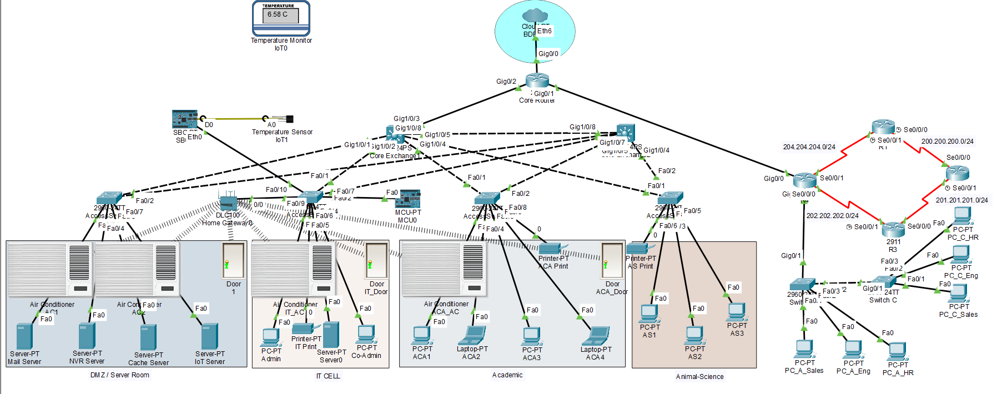
Figure1: Campus Network Topology
Campus Network (Main Site)
- Core Router (Cisco 2911): G0/2 to Core Exchange1 (192.168.0.1/24), G0/1 to R4 (203.203.203.2/24).
- Core Exchange1 (Cisco 3650‑24PS): SVIs for VLANs 10,20,30,60,100; trunk ports to access switches.
- Access Switches (Cisco 2960) for each VLAN (IT_CELL, SERVER_ROOM, ANIMAL_SCIENCE, ACADEMIC).
- End devices: Admin PC (192.168.10.10), Co‑admin laptop (192.168.10.12), IT Printer (192.168.10.50); Mail Server (192.168.20.10), NVR (192.168.20.11), Cache (192.168.20.12); Animal Science PCs (192.168.30.10‑13), Animal Printer (192.168.30.51); Academic PCs (192.168.60.10‑14), Academic Printer (192.168.60.50).
- Web Server (Server‑PT) at 192.168.10.200 (connected to Access Switch1, VLAN 10).
- IoT: Home Gateway (192.168.10.210), SBC‑PT (192.168.10.221), analog temperature sensor.

Figure 2: Remote Site Network
Remote Site Network
- Routers R1, R2, R3, R4 (Cisco 2911 with HWIC‑2T).
- Serial links (DCE on left side):
- R1 s0/0/0 (200.200.200.1/24) – R2 s0/0/0 (200.200.200.2/24)
- R2 s0/0/1 (201.201.201.1/24) – R3 s0/0/0 (201.201.201.2/24)
- R3 s0/0/1 (202.202.202.1/24) – R4 s0/0/0 (202.202.202.2/24)
- R4 G0/0**: 203.203.203.1/24 (to Core Router).
- R4 G0/1** subinterfaces:
- G0/1.10 (VLAN 10): 10.10.10.1/24
- G0/1.20 (VLAN 20): 10.10.20.1/24
- G0/1.30 (VLAN 30): 10.10.30.1/24
- Switch A (Cisco 2960): trunk to R4 G0/1 and to Switch C; access ports for VLANs 10,20,30.
- Switch C (Cisco 2960): trunk to Switch A; access ports for VLANs 10,20,30.
End devices (static IPs):
Device | VLAN | IP Address | Gateway
PC_A_Sales | 10 | 10.10.10.10 | 10.10.10.1
PC_A_Eng | 20 | 10.10.20.10 | 10.10.20.1
PC_A_HR | 30 | 10.10.30..10 | 10.10.30.1
PC_C_Sales | 10 | 10.10.10.20 | 10.10.10.1
PC_C_Eng | 20 | 10.10.20.20 | 10.10.20.1
PC_C_HR | 30 | 10.10.30.20 | 10.10.30.1


Figure 3: Full network topology (Logical view)

VLAN & Inter‑VLAN Routing (Campus)
VLANs were configured on Core Exchange1 (see Figure 2).
VLAN ID | Name | Subnet | SVI IP
10 | IT_CELL | 192.168.10.0/24 | 192.168.10.1
20 | SERVER_ROOM | 192.168.20.0/24 | 192.168.20.1
30 | ANIMAL_SCIENCE | 192.168.30.0/24 | 192.168.30.1
60 | ACADEMIC | 192.168.60.0/24 | 192.168.60.1
100 | TRANSIT | 192.168.0.0/24 | 192.168.0.2

Trunk ports (Gig1/0/1, Gig1/0/3) allowed all VLANs with native VLAN 100.
Configuration (Core Exchange1):
enable
configure terminal
ip routing
vlan 10
name IT_CELL
vlan 20
name SERVER_ROOM
vlan 30
name ANIMAL_SCIENCE
vlan 60
name ACADEMIC
vlan 100
name TRANSIT
interface vlan10
ip address 192.168.10.1 255.255.255.0
no shutdown
interface vlan20
ip address 192.168.20.1 255.255.255.0
no shutdown
interface vlan30
ip address 192.168.30.1 255.255.255.0
no shutdown
interface vlan60
ip address 192.168.60.1 255.255.255.0
no shutdown
interface vlan100
ip address 192.168.0.2 255.255.255.0
no shutdown
interface GigabitEthernet1/0/1
switchport mode trunk
switchport trunk native vlan 100
switchport trunk allowed vlan 10,20,30,60,100
no shutdown
interface GigabitEthernet1/0/3
switchport mode trunk
switchport trunk native vlan 100
switchport trunk allowed vlan 10,20,30,60,100
no shutdown
ip route 0.0.0.0 0.0.0.0 192.168.0.1
end
write memory
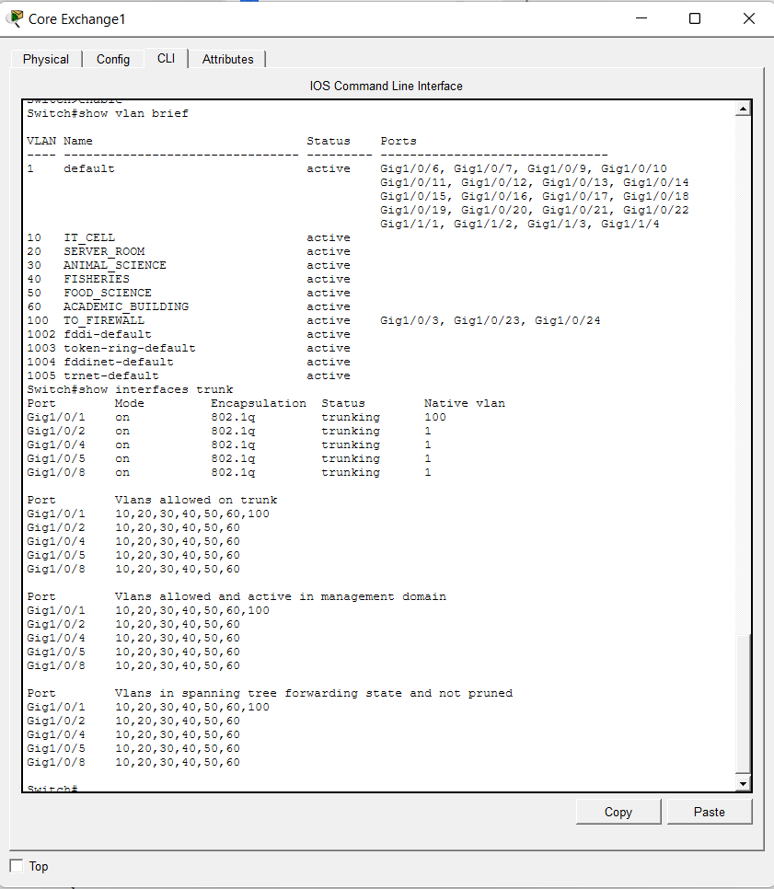
Figure 4: Core Exchange1 Configuration

Access Switch Configuration (IT_CELL – Access Switch1)
Each access switch in the campus was configured with the appropriate VLAN and trunk ports. The following configuration applies to Access Switch1 (IT_CELL), which connects the Admin PC, the web server, and the Home Gateway.
Configuration commands for Access Switch1 (Cisco 2960):
enable
configure terminal
hostname Access_Switch1
vlan 10
name IT_CELL
exit
interface fastEthernet0/2
switchport mode access
switchport access vlan 10
spanning-tree portfast
no shutdown
interface fastEthernet0/6
switchport mode access
switchport access vlan 10
spanning-tree portfast
no shutdown
interface fastEthernet0/9
switchport mode access
switchport access vlan 10
spanning-tree portfast
no shutdown
interface fastEthernet0/1
switchport mode trunk
switchport trunk native vlan 100
switchport trunk allowed vlan 10,20,30,60,100
no shutdown
end
write memory
Explanation of ports:
- Fa0/2 – Admin PC (192.168.10.10)
- Fa0/6 – Web Server (192.168.10.200)
- Fa0/9 – Home Gateway (192.168.10.210)
- Fa0/1 – Trunk to Core Exchange1 (carries all VLANs)
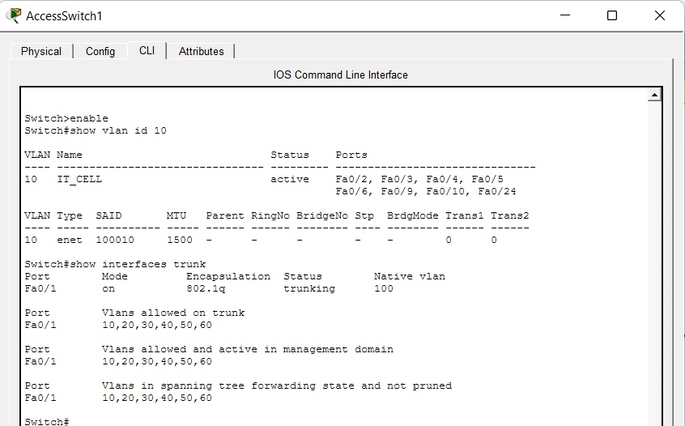
Figure 5: Access Switch1 Configuration
Similar configurations were applied to other access switches (SERVER_ROOM, ANIMAL_SCIENCE, ACADEMIC) with their respective VLANs (20,30,60).
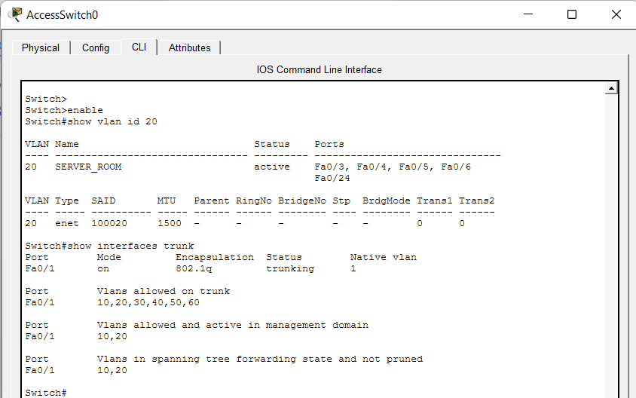
Figure 6: Access Switch0 Configuration
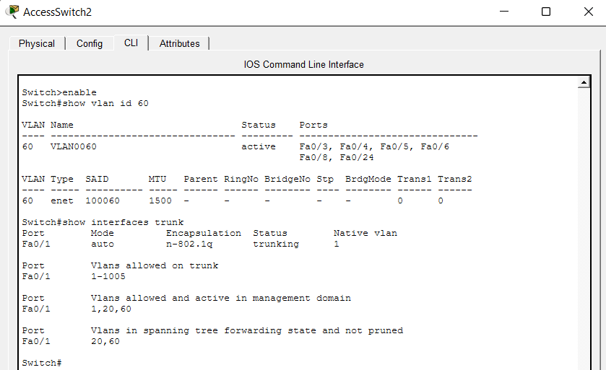
Figure 7: Access Switch2 Configuration
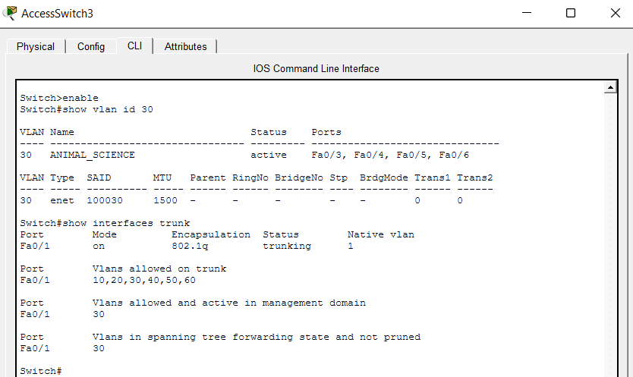
Figure 8: Access Switch3 Configuration

Remote Site Serial Link Configuration
Each remote router was configured with serial IPs and default routes pointing toward R4.
R1:
enable
configure terminal
hostname R1
interface Serial0/0/0
ip address 200.200.200.1 255.255.255.0
clock rate 64000
no shutdown
ip route 0.0.0.0 0.0.0.0 200.200.200.2
end
write memory
R2:
enable
configure terminal
hostname R2
interface Serial0/0/0
ip address 200.200.200.2 255.255.255.0
no shutdown
interface Serial0/0/1
ip address 201.201.201.1 255.255.255.0
clock rate 64000
no shutdown
ip route 0.0.0.0 0.0.0.0 201.201.201.2
end
write memory
R3:
enable
configure terminal
hostname R3
interface Serial0/0/0
ip address 201.201.201.2 255.255.255.0
no shutdown
interface Serial0/0/1
ip address 202.202.202.1 255.255.255.0
clock rate 64000
no shutdown
ip route 0.0.0.0 0.0.0.0 202.202.202.2
end
write memory
R4:
enable
configure terminal
hostname R4
interface Serial0/0/0
ip address 202.202.202.2 255.255.255.0
no shutdown
interface GigabitEthernet0/0
ip address 203.203.203.1 255.255.255.0
no shutdown
interface GigabitEthernet0/1
no ip address
no shutdown
interface GigabitEthernet0/1.10
encapsulation dot1Q 10
ip address 10.10.10.1 255.255.255.0
interface GigabitEthernet0/1.20
encapsulation dot1Q 20
ip address 10.10.20.1 255.255.255.0
interface GigabitEthernet0/1.30
encapsulation dot1Q 30
ip address 10.10.30.1 255.255.255.0
ip route 0.0.0.0 0.0.0.0 203.203.203.2
end
write memory
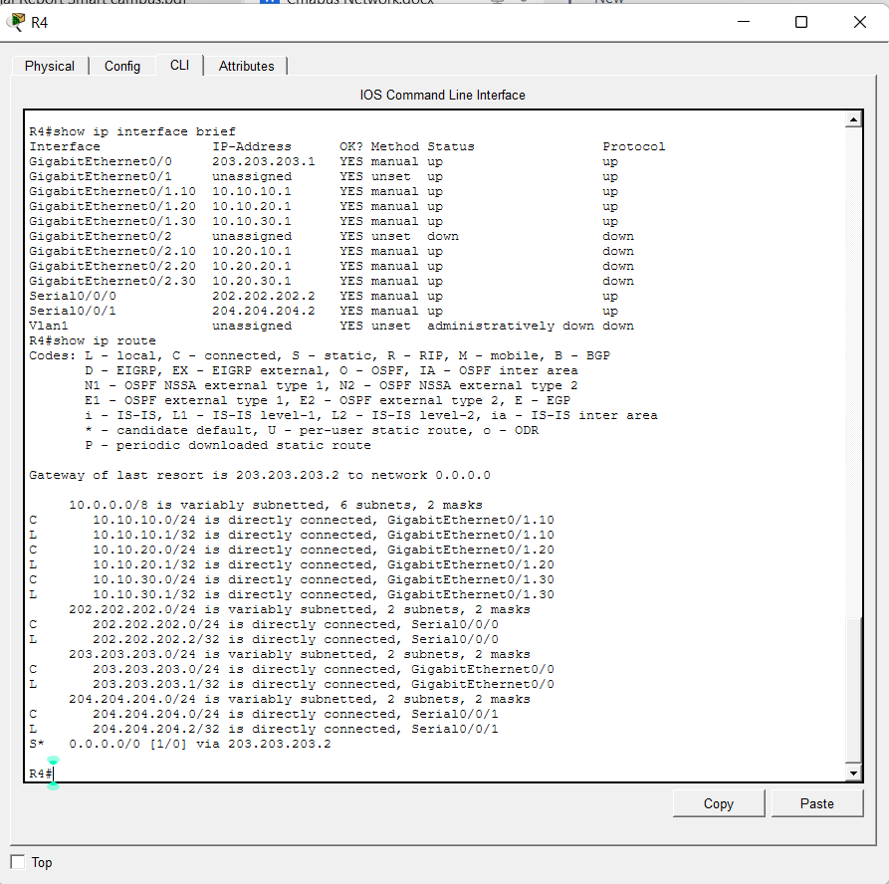
Figure 9: Router R4 Configuration

Inter‑Campus Static Routing
On the Core Router:
enable
configure terminal
hostname Core_Router
interface GigabitEthernet0/2
ip address 192.168.0.1 255.255.255.0
no shutdown
interface GigabitEthernet0/1
ip address 203.203.203.2 255.255.255.0
no shutdown
ip route 192.168.10.0 255.255.255.0 192.168.0.2
ip route 192.168.20.0 255.255.255.0 192.168.0.2
ip route 192.168.30.0 255.255.255.0 192.168.0.2
ip route 192.168.60.0 255.255.255.0 192.168.0.2
ip route 10.10.10.0 255.255.255.0 203.203.203.1
ip route 10.10.20.0 255.255.255.0 203.203.203.1
ip route 10.10.30.0 255.255.255.0 203.203.203.1
end
write memory
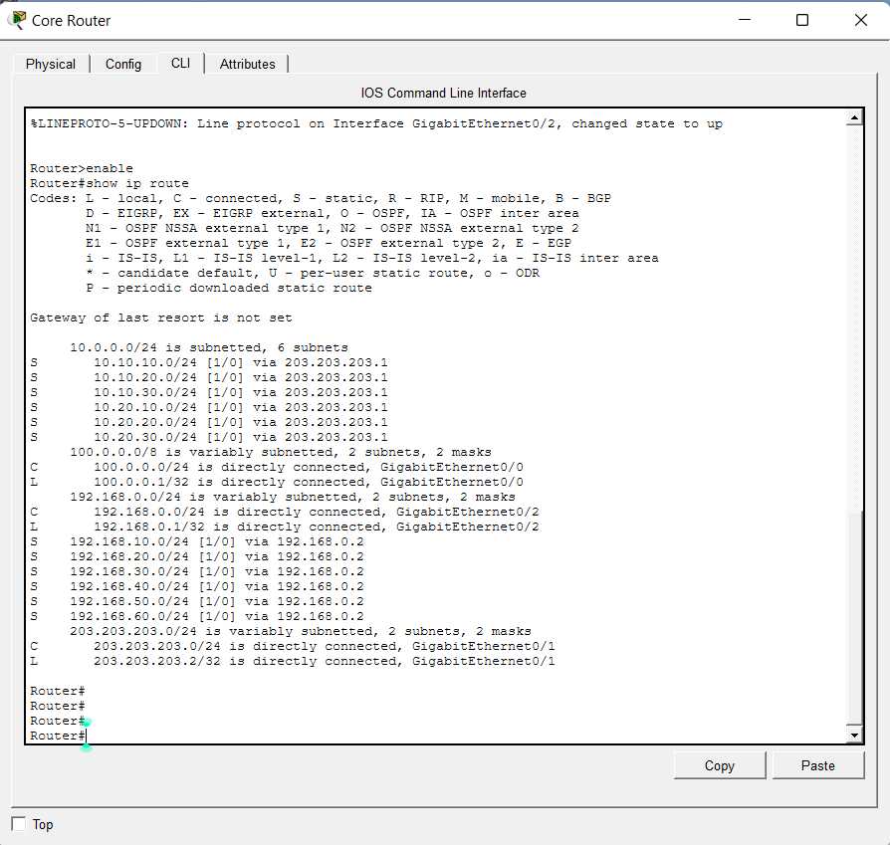
Figure 10: Core Router Configuration

Access Control List (ACL)
Extended ACL 101 was applied outbound on R4’s G0/0 to restrict PC_C_HR (10.10.30.20) to only Admin PC (192.168.10.10) and the web server (192.168.10.200).
enable
configure terminal
access-list 101 remark Restrict PC_C_HR to Admin PC and Web Server
access-list 101 permit ip host 10.10.30.20 host 192.168.10.10
access-list 101 permit ip host 10.10.30.20 host 192.168.10.200
access-list 101 deny ip host 10.10.30.20 192.168.0.0 0.0.255.255
access-list 101 permit ip any any
interface GigabitEthernet0/0
ip access-group 101 out
end
write memory
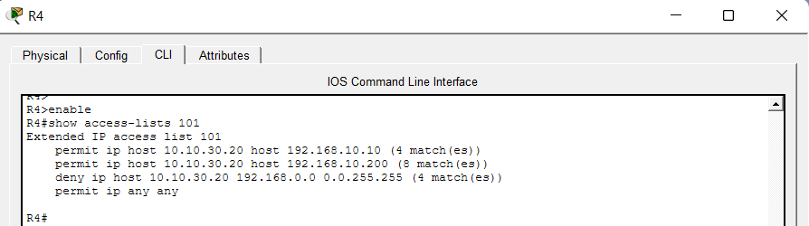
Figure 11: R4 ACL Configuration

Email Server Configuration
The mail server at 192.168.20.10 (Server‑PT) was configured as follows:
- IP configuration – Static IP 192.168.20.10, mask 255.255.255.0, gateway 192.168.20.1.
- Services → EMAIL:
- SMTP Service: ON
- POP3 Service: ON
- Domain Name: `university.edu`
3. Users:
- `admin` with password `admin` (SMTP & POP3 enabled)
- `coadmin` with password `coadmin` (SMTP & POP3 enabled)
- `animal` with password `animal` (SMTP & POP3 enabled)
- `academic` with password `academic` (SMTP & POP3 enabled)
- `sales1` with password `sales1` (SMTP & POP3 enabled)
- `sbc` with password `password` (SMTP & POP3 enabled)
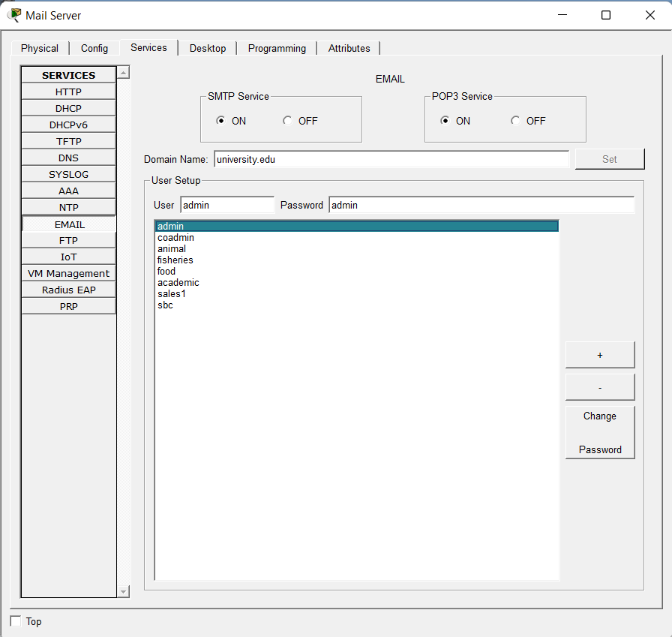
Figure 12: Mail server email service configuration with user list
Admin PC email client (192.168.10.10):
- Incoming/Outgoing Mail Server: `192.168.20.10`
- User Name: `admin`, Password: `admin`
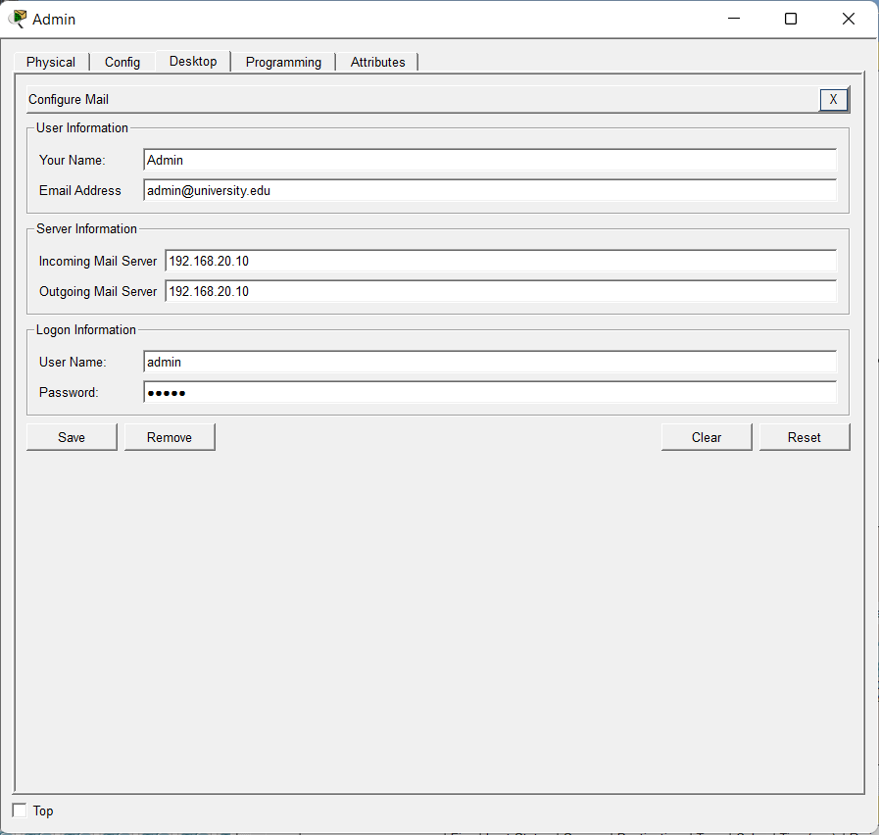
Figure 13: Admin PC email client settings

Web Server Configuration
The web server at 192.168.10.200 (Server‑PT) was configured:
Services → HTTP: ON
A simple `index.html` file was created (default or custom).
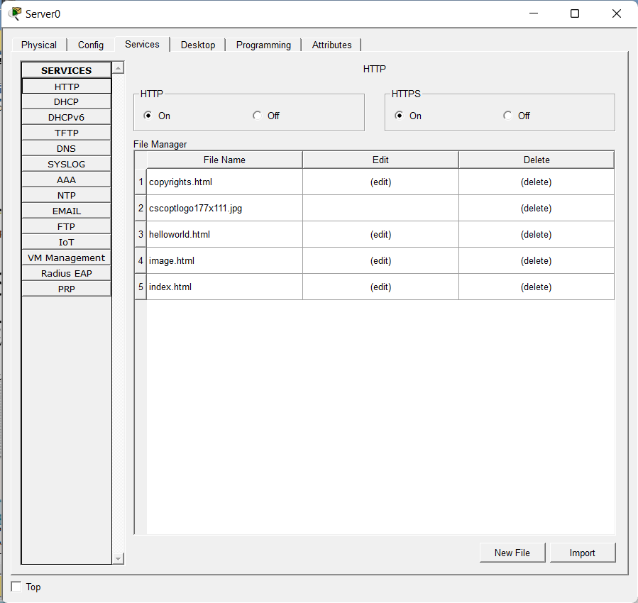
Figure 14: Web server HTTP service window

IoT Integration – Temperature Sensor & Email Alerts
Hardware Connections
- Temperature sensor (analog) → SBC‑PT: Use the blue IoT cable (Connections). Connect sensor pin A0 to SBC‑PT pin D0.
- SBC‑PT → Access Switch1: Use Copper Straight‑Through cable from SBC‑PT `Ethernet0` to switch port `Fa0/10` (VLAN 10).
- Home Gateway → Access Switch1: Already connected via `Internet` port to `Fa0/9` (VLAN 10). Static IP: 192.168.10.210, mask 255.255.255.0, gateway 192.168.10.1. Wireless SSID `IOT_NET`.
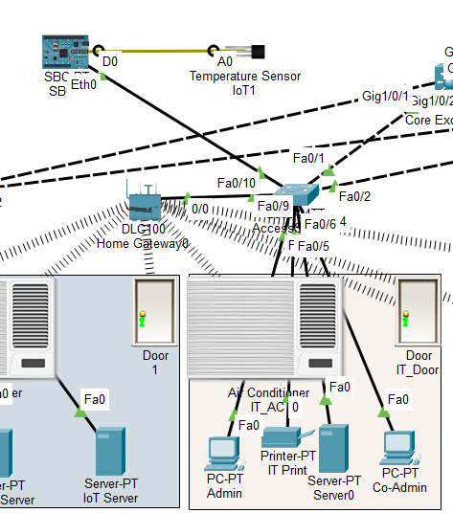
Figure 15: Physical connections (SBC‑PT, temperature sensor, switch)
SBC‑PT Static IP
- IP Address: `192.168.10.221`
- Subnet Mask: `255.255.255.0`
- Default Gateway: `192.168.10.1`
Python Script (Uploaded to SBC‑PT)
from time import *
from gpio import *
from email import *
MAIL_SERVER = "192.168.20.10"
SENDER_EMAIL = "sbc@university.edu"
SENDER_USER = "sbc"
SENDER_PASS = "password"
RECIPIENT = "admin@university.edu"
TEMP_ON = 7 # >=7°C -> Turn ON ACs
TEMP_OFF = 7 # <7°C -> Turn OFF ACs
alert_on_sent = False
alert_off_sent = False
def get_temperature():
# Read analog value from D0 pin (0-1023)
raw = analogRead(0)
# Convert to Celsius (adjust formula if needed)
celsius = (raw / 1023.0) * 100.0 - 50.0
return celsius
def send_alert(subject, message):
try:
EmailClient.setup(SENDER_EMAIL, MAIL_SERVER, SENDER_USER, SENDER_PASS)
EmailClient.send(RECIPIENT, subject, message)
print("Email sent: " + subject)
except Exception as e:
print("Email error:", e)
while True:
temp = get_temperature()
print("Temperature: {:.1f}°C".format(temp))
if temp >= TEMP_ON and not alert_on_sent:
send_alert("Temperature Alert: Turn ON ACs",
"Temperature reached {:.1f}°C. Turn ON ACs.".format(temp))
alert_on_sent = True
alert_off_sent = False
elif temp < TEMP_OFF and not alert_off_sent:
send_alert("Temperature Alert: Turn OFF ACs",
"Temperature dropped to {:.1f}°C. Turn OFF ACs.".format(temp))
alert_off_sent = True
alert_on_sent = False
sleep(30)

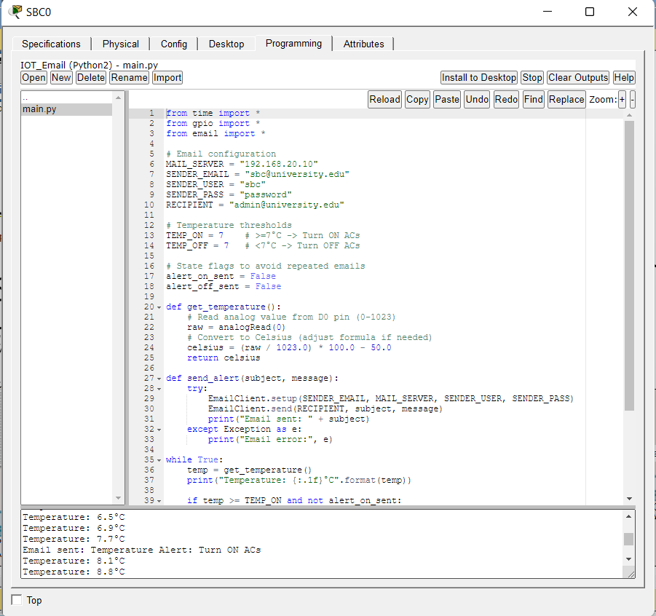
Figure 16: SBC‑PT programming tab with script and console output

Results and Discussion

Connectivity Tests (All Devices)
Comprehensive ping tests were performed from various source devices to destination devices across both campus and remote networks. The results are summarized below.
Source Device | Source IP | Destination Device | Destination IP | Expected | Result
Admin PC | 192.168.10.10 | Mail Server | 192.168.20.10 | Success | Success
Admin PC | 192.168.10.10 | PC_C_HR | 10.10.30.20 | Success | Success
PC_A_Sales | 10.10.10.10 | Admin PC | 192.168.10.10 | Success | Success
PC_A_Sales | 10.10.10.10 | PC_C_HR | 10.10.30.20 | Success | Success
PC_C_HR | 10.10.30.20 | Admin PC | 192.168.10.10 | Success | Success
PC_C_HR | 10.10.30.20 | Web Server | 192.168.10.200 | Success | Success
PC_C_HR | 10.10.30.20 | Mail Server | 192.168.20.10 | Fail (blocked) | Destination unreachable
PC_C_HR | 10.10.30.20 | Animal Science PC | 192.168.30.10 | Fail (blocked) | Destination unreachable
SBC-PT | 192.168.10.221 | Mail Server | 192.168.20.10 | Success | Success
R4 | 203.203.203.1 | Core Router | 203.203.203.2 | Success | Success

Key decisions based on these results:
The ACL was placed outbound on R4’s G0/0 after initially testing inbound (which did not block outgoing traffic). This change ensured that traffic from PC_C_HR to the existing network was filtered correctly.
Static routes on the Core Router for remote subnets (10.10.x.0/24) were verified and kept. Default routes on R1,R2,R3 pointing toward R4 were confirmed to be correct.
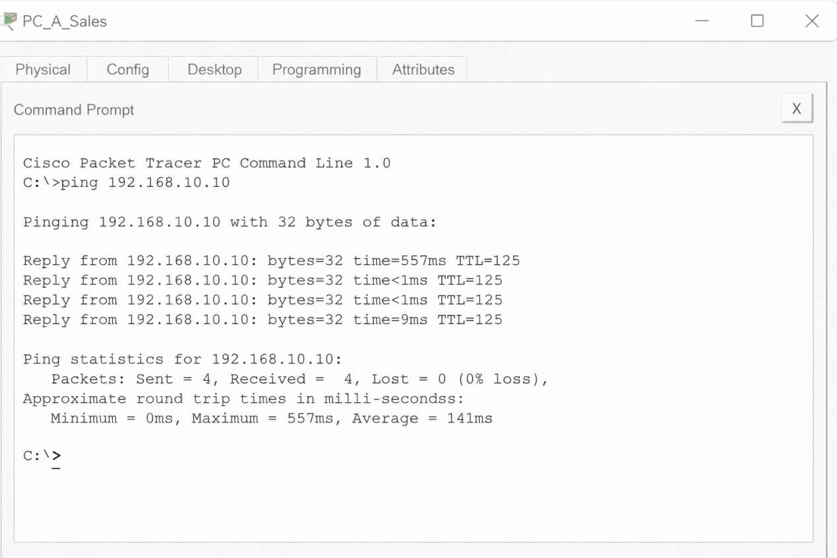
Figure 17 : Ping From PC_A_Sales to Admin PC

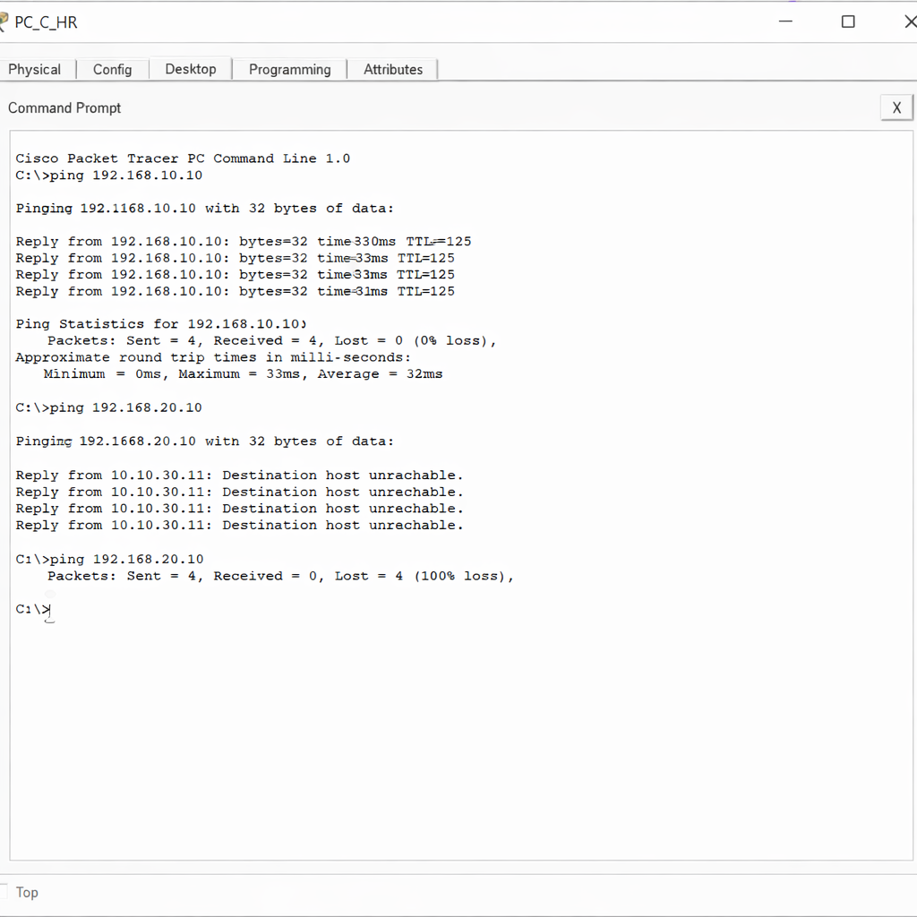
Figure 18: Ping from PC_C_HR to Admin PC

Figure 19: Ping from PC_C_HR to Mail Server
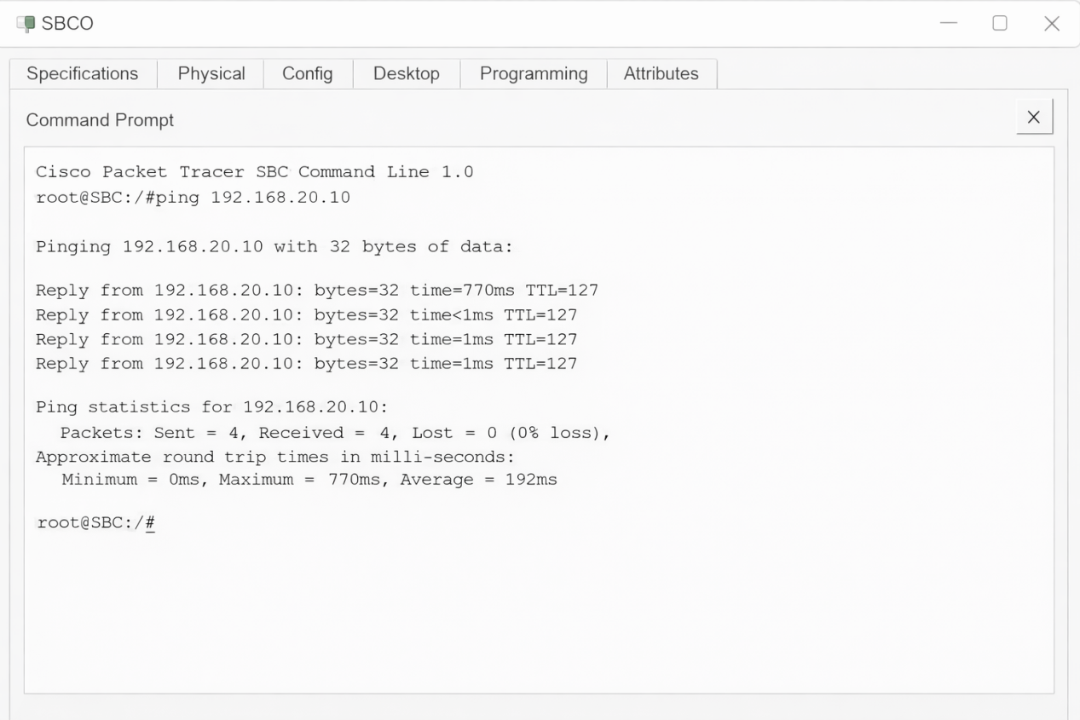
Figure 20: Ping from SBC to Mail Server

ACL Verification
From PC_C_HR, browsing `http://192.168.10.200` succeeded, but any attempt to ping or access other 192.168.x.x addresses failed. This confirmed that the ACL correctly restricts the host to only the Admin PC and the web server.
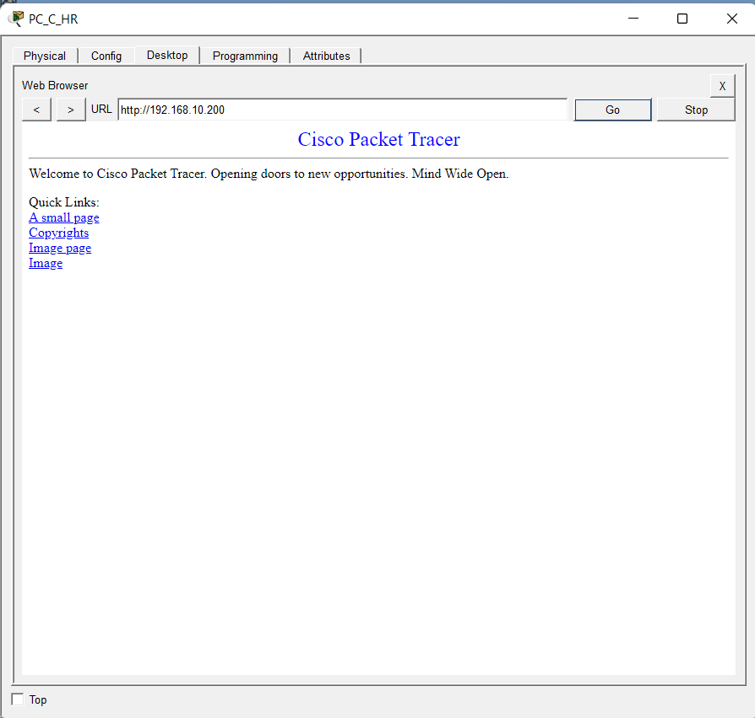
Figure 21: Web browser on PC_C_HR showing web server page

Email Automation Tests
The ambient temperature was varied using Physical → Environment. At 8 °C, the SBC‑PT console printed “Email sent to: admin@university.edu” and the Admin PC’s email client received the “Turn ON ACs” email. At 6 °C, the “Turn OFF ACs” email arrived. The delay was 30 seconds (the script’s sleep interval).
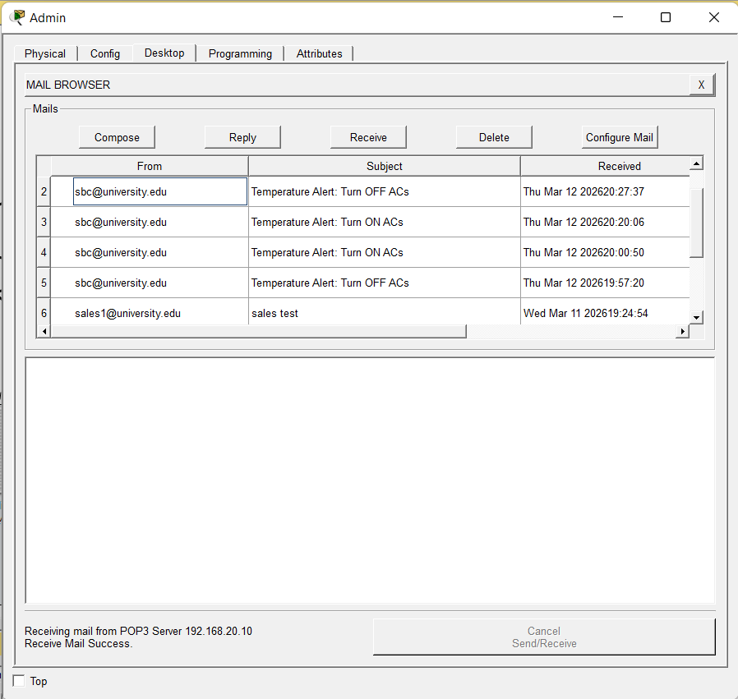
Figure 22: Admin PC inbox showing both alert emails

System Limitations
- Sensor accuracy – The conversion formula `(raw/1023)100-50` is approximate; calibration would be needed in a real deployment.
- Email reliability – The `sendEmail()` function works, but in some Packet Tracer versions emails may require manual “Send/Receive” clicks.
- No automatic AC control – Only email alerts are sent; actual AC switching would require additional hardware/actuators.

Limitations & Challenges

Network Design Challenges
- Ensuring inter‑VLAN routing between campus VLANs and remote site VLANs required careful static route configuration.
- The native VLAN mismatch on the trunk between Core Exchange1 and Access Switch1 caused initial connectivity failures; it was resolved by setting native VLAN 100 on both sides.

Hardware/Software Limitations
- Packet Tracer’s SBC‑PT does not have dedicated analog pins; however, `analogRead(0)` on digital pin D0 was found to work for reading the analog temperature sensor – a workaround that was successfully tested.
- The Home Gateway’s GUI lacked a rules engine, so the SBC‑PT was used for automation instead.

Practical Issues Encountered
- The Home Gateway initially did not respond to ping or HTTP; replacing it with a fresh device solved the problem.
- The ACL was first applied inbound, which did not block outgoing traffic; changing to outbound fixed the issue.
- Email delivery failed until the mail server’s domain name was set and the user `sbc` was created.

Risks and Mitigation
Risk | Mitigation
Routing misconfiguration | Step‑by‑step verification with `show ip route` and ping tests after each addition.
ACL blocking essential traffic | Tested ACL with specific permit statements before deny; applied on outbound direction.
Email server unreachable | Configured static routes, verified connectivity with ping, and ensured SMTP/POP3 services were on.
Sensor reading failure | Used `analogRead(0)` on D0; validated with console output before email integration.
Packet Tracer limitations | Documented workarounds (e.g., using D0 for analog read) and provided clear explanations for the report.

Knowledge Categories (K1–K8)
Category | Coverage in Project
K1: Depth of Knowledge | Advanced concepts: VLANs, inter‑VLAN routing, static routing, extended ACLs, IoT programming (Python on SBC‑PT), email protocols.
K2: Knowledge of Disciplines | Combines computer networking (Cisco IOS) with IoT (sensors, SBC programming) and email services.
K3: Engineering Practice | Applied IEEE 802.1Q for VLAN trunking, RFC 821 (SMTP), and standard IP addressing. Used systematic configuration and testing.
K4: Research & Investigation | Investigated native VLAN mismatch, ACL direction issues, and email delivery problems; found working solutions.
K5: Problem Analysis | Analyzed routing failures, sensor reading on digital pin, and email client configuration; applied logical troubleshooting.
K6: Design & Development | Designed hierarchical IP addressing, VLAN segmentation, static routing tables, and Python automation script.
K7: Tools & Techniques | Used Cisco Packet Tracer, CLI commands, Python scripting, and email client simulation.
K8: Social & Environmental Impact | Enables energy‑efficient HVAC control, reduces electricity waste, and supports sustainable campus operations.

Complex Engineering Problem Attributes (P1–P7)
Attribute | Project Alignment
P1: Depth of Knowledge | Requires deep understanding of routing, ACLs, VLANs, and IoT programming to integrate all components.
P2: Wide‑Ranging Issues | Balances security (ACL) with functionality (email alerts, remote access) and manages multiple address domains.
P3: Abstract Thinking | Logical design of static routes, ACL logic, and temperature threshold automation.
P4: Infrequently Encountered Issues | Using `analogRead(0)` on a digital pin of SBC‑PT; sending emails from an IoT device in Packet Tracer.
P5: Standards Compliance | Follows IEEE 802.1Q, RFC 791 (IPv4), SMTP/POP3 standards.
P6: Stakeholder Conflicts | Different users (admin, remote staff, IoT devices) have different access levels; VLANs and ACLs resolve conflicts.
P7: Interdependent Components | Routing, email, and IoT automation are interdependent – a routing failure breaks email alerts; each component tested in isolation and then integrated.

Complex Engineering Activities
Attribute | Description
A1: Range of resources | Involve the use of diverse resources (and for this purpose resources include people, money, equipment, materials, information and technologies)
A2: Level of interaction | Require resolution of significant problems arising from interactions between wide-ranging or conflicting technical, engineering or other issues
A3: Innovation | Involve creative use of engineering principles and research-based knowledge in novel ways
A4: Consequences for society and the environment | Have significant consequences in a range of contexts, characterized by difficulty of prediction and mitigation
A5: Familiarity | Can extend beyond previous experiences by applying principles-based approaches

Conclusion
The project successfully designed and implemented a converged university campus network with a remote site connected via a four‑router serial chain. Key accomplishments include:
- Full IPv4 connectivity between the main campus (VLANs 10,20,30,60,100) and the remote site (VLANs 10,20,30 over R1‑R4).
- An extended ACL on R4 that restricts PC_C_HR to only the Admin PC (192.168.10.10) and a dedicated web server (192.168.10.200).
- A fully functional email server (SMTP/POP3) with user accounts `admin` and `sbc`, delivering alerts to the administrator.
- An IoT automation system using an SBC‑PT and an analog temperature sensor (connected to D0) that sends real email alerts at 7 °C (turn ON ACs) and below 7 °C (turn OFF ACs).
All objectives were met, and the system was verified through ping tests, ACL checks, and email delivery tests in Cisco Packet Tracer. The project demonstrates practical skills in network design, configuration, security, and IoT programming, providing a scalable and secure solution for smart campus environments.

Future Work
- Replace email alerts with direct AC control – Use relays or smart plugs controlled by the SBC‑PT.
- Implement dynamic routing (OSPF) for automatic failover and easier expansion.
- Add a secondary serial link between R1 and R4 with floating static routes for redundancy.
- Enable IPv6 on all routers and end devices (dual‑stack).
- Log temperature data to a database for historical analysis.
- Integrate a web dashboard for real‑time sensor monitoring and manual override.

References
[1] Cisco Systems, “Cisco IOS IP Routing: Protocol-Independent Configuration Guide,” Cisco Press, 2020.
[2] J. F. Kurose and K. W. Ross, Computer Networking: A Top‑Down Approach, 8th ed. Pearson, 2020.
[3] Cisco Networking Academy, “Introduction to IoT,” Cisco Press, 2019.
[4] Packet Tracer Network Simulator, “Environmental Settings and IoT,” Cisco Systems, 2023.
[5] A. S. Tanenbaum and D. J. Wetherall, Computer Networks, 5th ed. Prentice Hall, 2011.
[6] M. S. Islam et al., “Internet of Things for Smart Agriculture,” Journal of Ambient Intelligence and Smart Environments, vol. 13, no. 2, pp. 123‑145, 2021.
[7] IEEE Standard for Local and Metropolitan Area Networks – 802.1Q, “Virtual Bridged Local Area Networks,” IEEE, 2018.
[8] Postel, J., “Simple Mail Transfer Protocol,” RFC 821, 1982.

Appendix: Screenshot Commands and Placeholders
Figure | Description | Device
Fig. 1 | Campus Topology | Packet Tracer main window
Fig. 2 | Remote Network Topology | Packet Tracer main window
Fig. 3 | Full Network Topology | Packet Tracer main window
Fig. 4 | Core Exchange1 Configuration | Core Exchange1
Fig. 5 | Access Switch1 Configuration | Access Switch1
Fig. 6 | Access Switch0 Configuration | Access Switch0
Fig. 7 | Access Switch2 Configuration | Access Switch2
Fig. 8 | Access Switch3 Configuration | Access Switch3
Fig. 9 | Router R4 Configuration | R4
Fig. 10 | Core Router Configuration | Core Router
Fig. 11 | R4 ACL Configuration | R4
Fig. 12 | Mail server email service configuration with user list | Mail Server
Fig. 13 | Admin PC email client settings | Admin PC
Fig. 14 | Web server HTTP service window | Server0
Fig. 15 | Physical connections (SBC‑PT, temperature sensor, switch) | Packet Tracer main window
Fig. 16 | SBC‑PT programming tab with script and console output | SBC
Fig. 17 | Ping From PC_A_Sales to Admin PC | PC_A_Sales
Fig. 18 | Ping from PC_C_HR to Admin PC | PC_C_HR
Fig. 19 | Ping from PC_C_HR to Mail Server | PC_C_HR
Fig. 20 | Ping from SBC to Mail Server | SBC
Fig. 21 | Web browser on PC_C_HR showing web server page | PC_C_HR
Fig. 22 | Admin PC inbox showing both alert emails | Admin PC

